Name: Pranali Sonawane
Subject: CCNA
Lab – Intra-VLAN :
First we have taken 2 switches and 4 pc’s. Pcs connected using straight through cable and switch are connected using cross over cable.

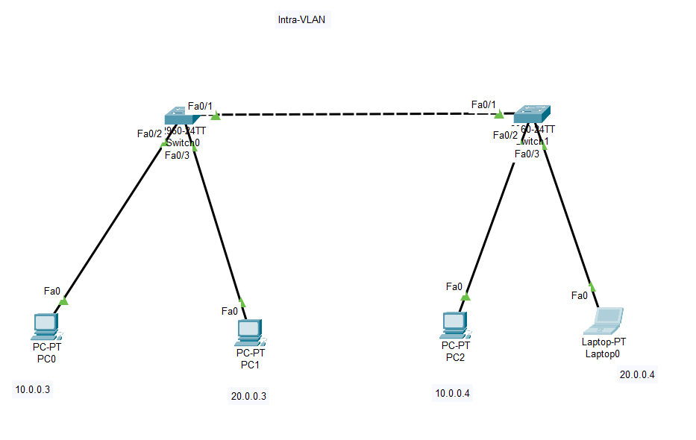
Configure PCs
- PC0:
  - IPv4 Address: 10.0.0.3
  - Subnet Mask: 255.0.0.0
- PC1:
  - IPv4 Address: 20.0.0.3
  - Subnet Mask: 255.0.0.0
- PC2:
  - IPv4 Address: 10.0.0.4
  - Subnet Mask: 255.0.0.0
- Laptop:
  - IPv4 Address: 20.0.0.4
  - Subnet Mask: 255.0.0.0
Open Switch 0 – CLI prompt then type following commands
Switch>enable
Switch#config terminal
For VLAN 10 :
Switch (config)#vlan 10
Switch (config-vlan)# name CCNA
Switch (config-vlan)#exit

Switch (config)#interface fastEthernet 0/2
Switch (config-if)#switchport mode access
Switch (config-if)#switchport access vlan 10
Switch (config-if)#exit

For VLAN 20 :
Switch (config)#vlan 20
Switch (config-vlan)#name MCSA
Switch (config-vlan)#exit

Switch (config)#interface fastEthernet 0/3
Switch (config-if)#switchport mode access
Switch (config-if)#switchport access vlan 20
Switch(config-if)#exit

To make interface common use Trunk :
Switch (config)#interface fastEthernet 0/1
Switch (config-if)#switchport mode trunk

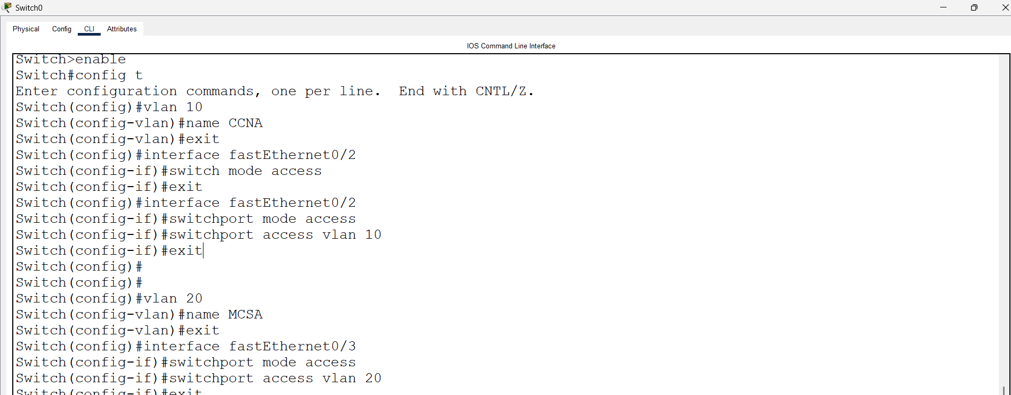

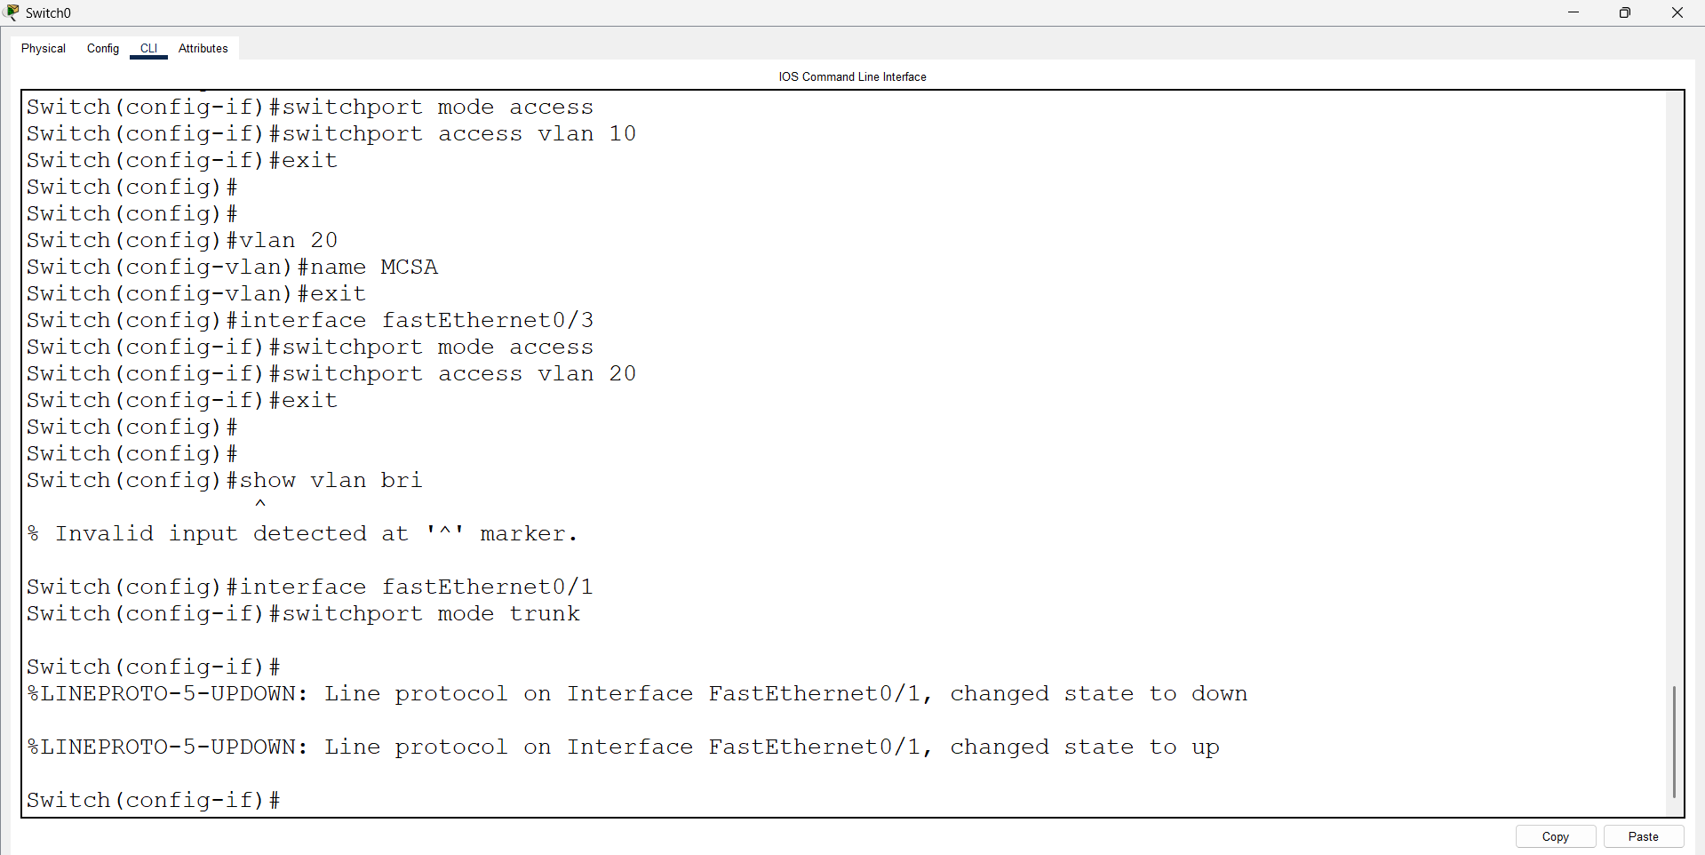

Go to Switch1 and enter following commands
Switch>enable
Switch>config terminal

For VLAN 10 :
Switch (config)#vlan 10
Switch (config-vlan) name CCNA
Switch (config-vlan)#exit

Switch (config)#interface fastEthernet 0/2
Switch (config-if)#switchport mode access
Switch (config-if)#switchport access vlan 10
Switch (config-if)#exit

For VLAN 20 :

Switch (config)#vlan 20
Switch (config-vlan) name MCSA
Switch (config-vlan)#exit

Switch (config)#interface fastEthernet 0/3
Switch (config-if)#switchport mode access
Switch (config-if)#switchport access vlan 20
Switch (config-if)#exit

To make interface common use Trunk :

Switch (config)#interface fastEthernet 0/1
Switch (config-if)#switchport mode trunk

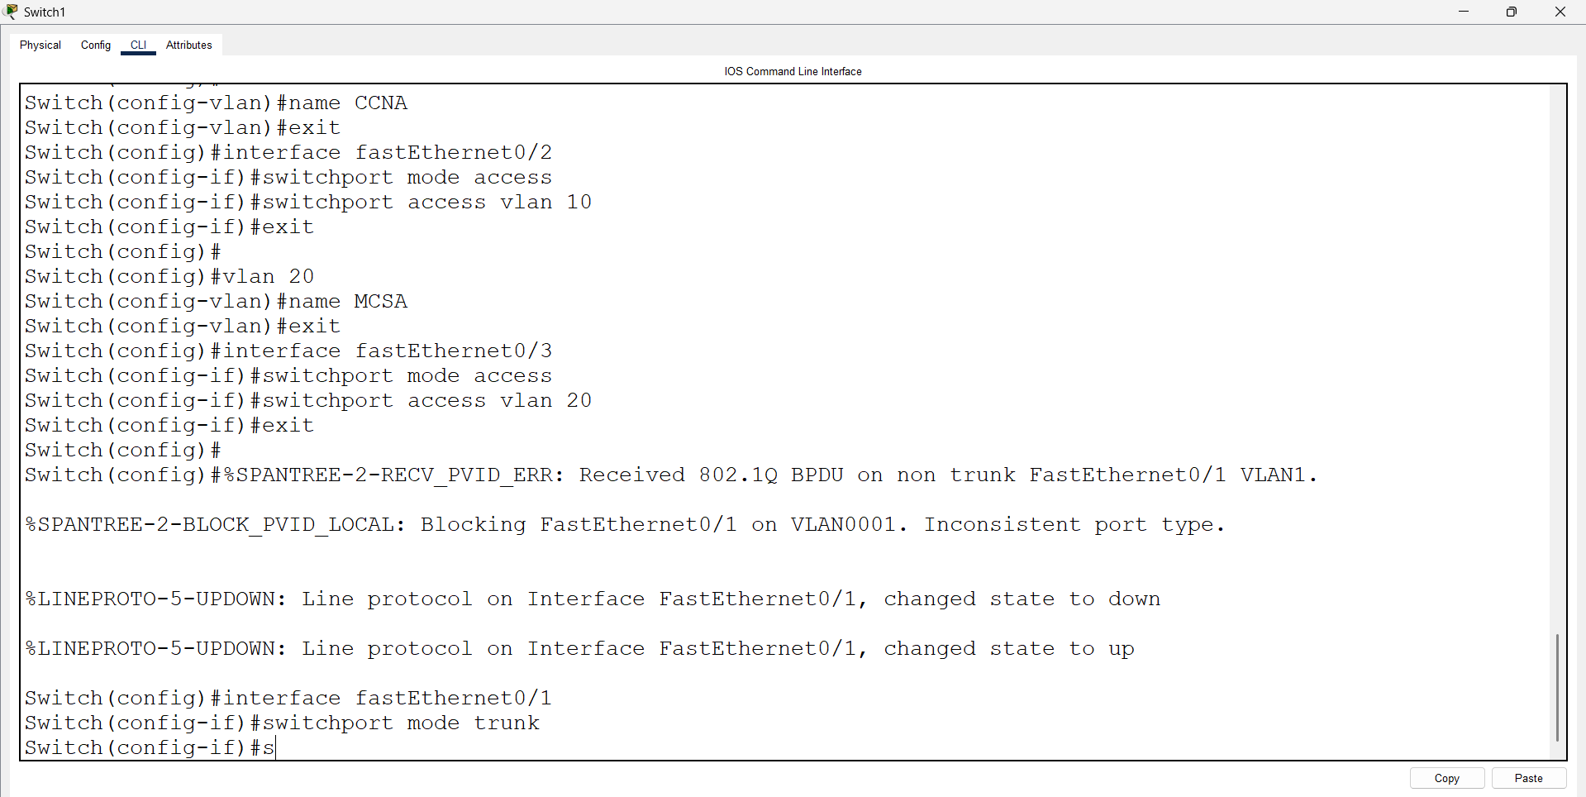

Open pc 0 – cmd prompt – type command
>ping 10.0.0.4

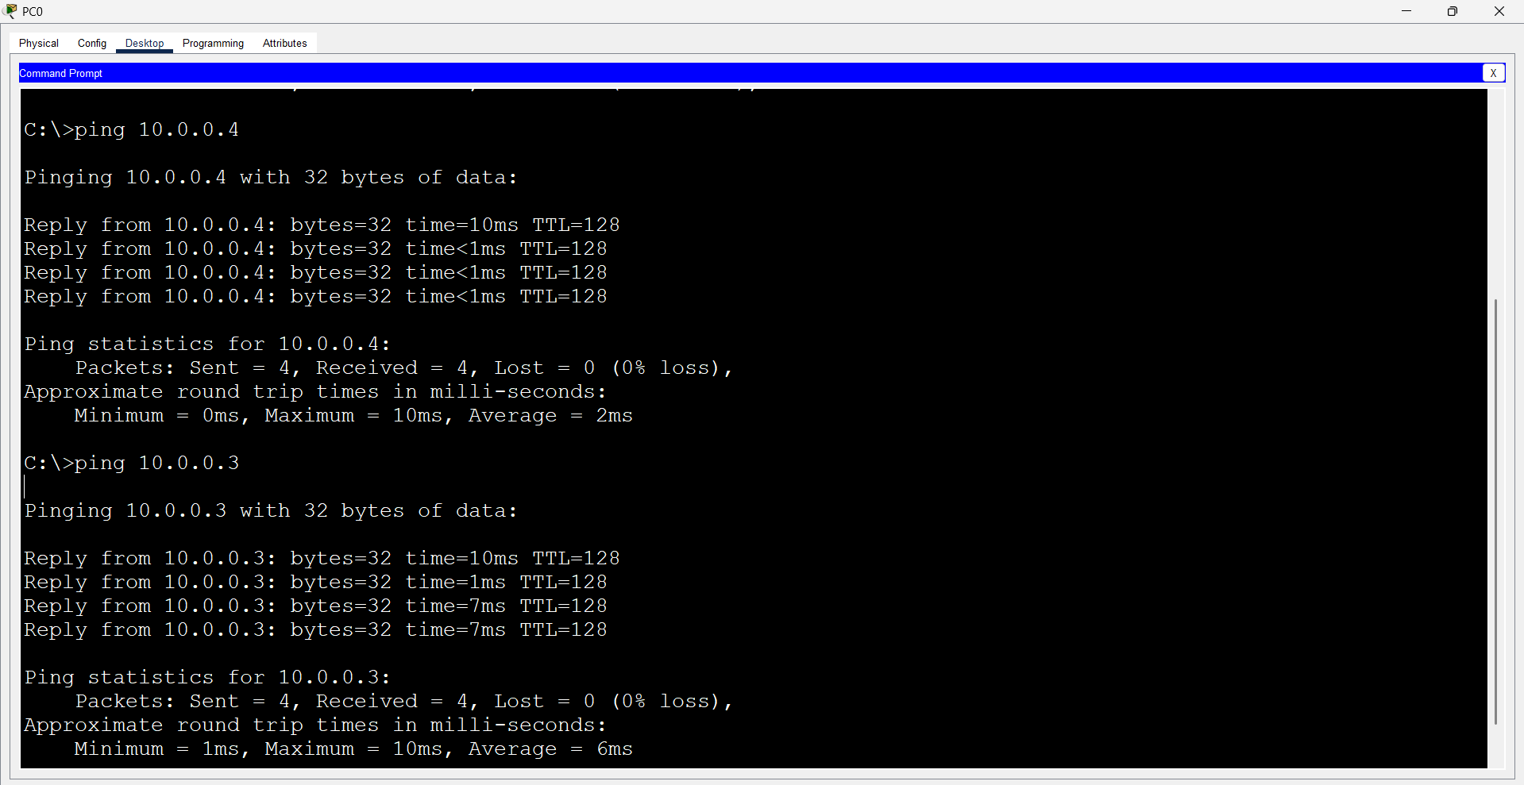
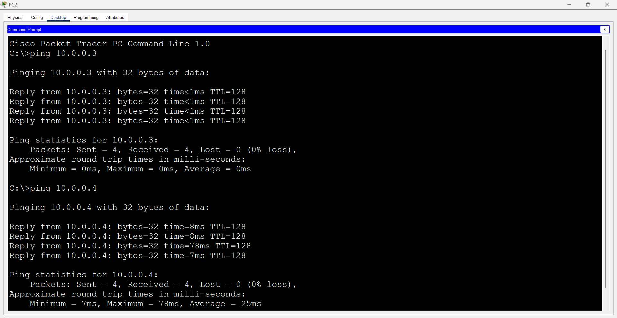

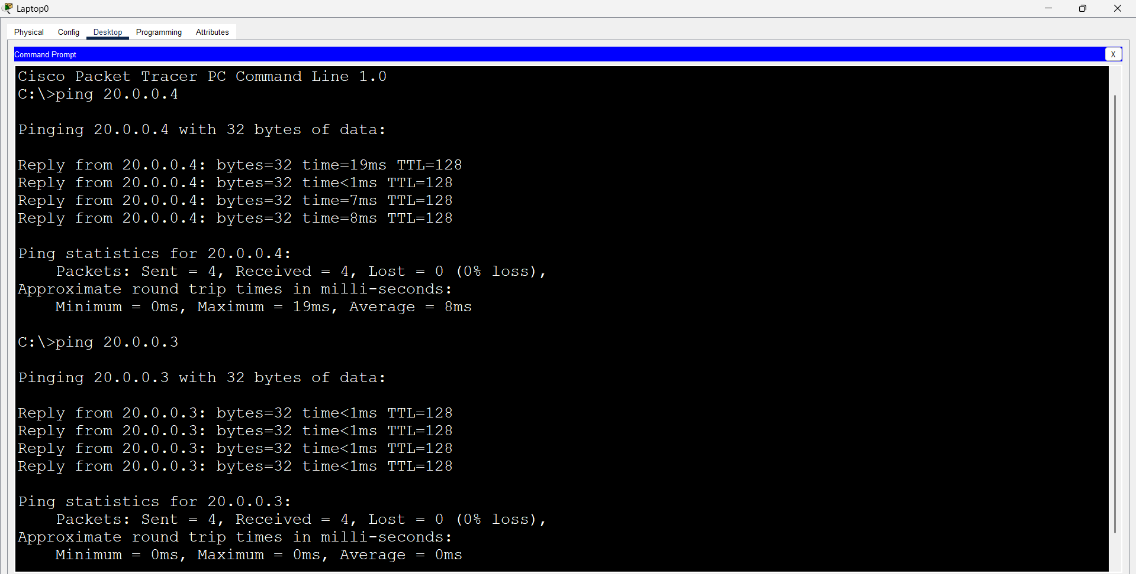

- First we have taken 3 switches and 6 pc’s. Pcs connected using straight through cable and switch are connected using cross over cable.

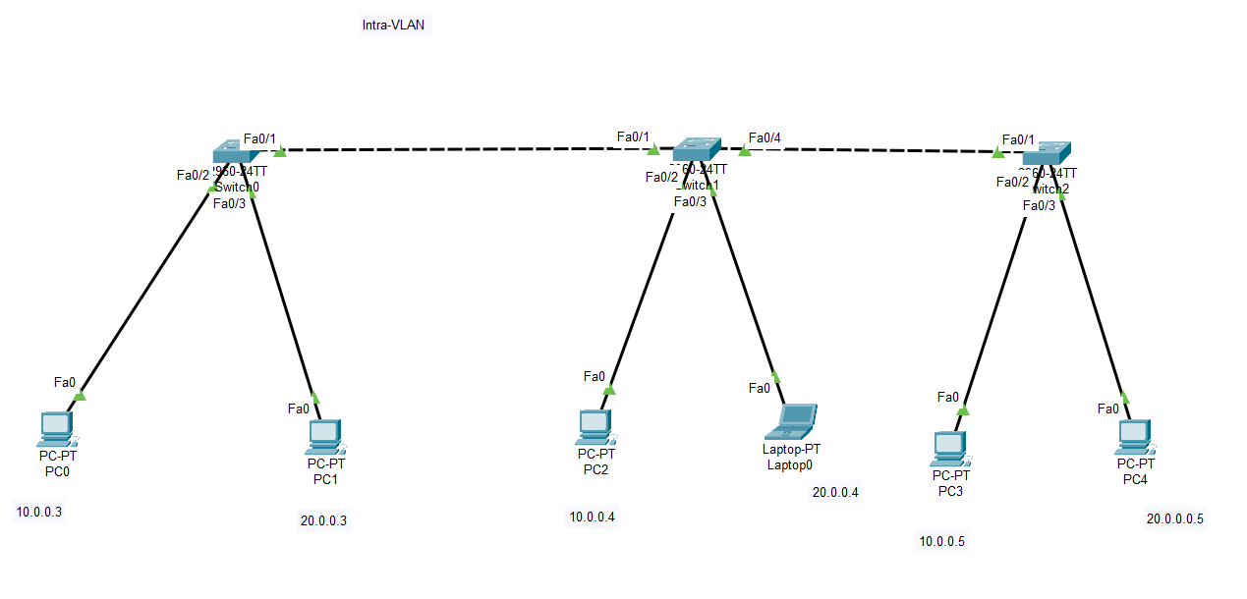
Configure PCs
- PC0:
  - IPv4 Address: 10.0.0.3
  - Subnet Mask: 255.0.0.0
- PC1:
  - IPv4 Address: 20.0.0.3
  - Subnet Mask: 255.0.0.0
- PC2:
  - IPv4 Address: 10.0.0.4
  - Subnet Mask: 255.0.0.0
- Laptop:
  - IPv4 Address: 20.0.0.4
  - Subnet Mask: 255.0.0.0
- PC3:
  - IPv4 Address: 10.0.0.5
  - Subnet Mask: 255.0.0.0
- PC4:
  - IPv4 Address: 20.0.0.5
  - Subnet Mask: 255.0.0.0

Open Switch 0 – CLI prompt then type following commands
Switch>enable
Switch#config terminal
For VLAN 10 :
Switch (config)#vlan 10
Switch (config-vlan)# name CCNA
Switch (config-vlan)#exit

Switch (config)#interface fastEthernet 0/2
Switch (config-if)#switchport mode access
Switch (config-if)#switchport access vlan 10
Switch (config-if)#exit

For VLAN 20 :
Switch (config)#vlan 20
Switch (config-vlan)#name MCSA
Switch (config-vlan)#exit

Switch (config)#interface fastEthernet 0/3
Switch (config-if)#switchport mode access
Switch (config-if)#switchport access vlan 20
Switch(config-if)#exit

To make interface common use Trunk :
Switch (config)#interface fastEthernet 0/1
Switch (config-if)#switchport mode trunk

Go to Switch1 and enter following commands
Switch>enable
Switch>config terminal

For VLAN 10 :
Switch (config)#vlan 10
Switch (config-vlan) name CCNA
Switch (config-vlan)#exit

Switch (config)#interface fastEthernet 0/2
Switch (config-if)#switchport mode access
Switch (config-if)#switchport access vlan 10
Switch (config-if)#exit

For VLAN 20 :

Switch (config)#vlan 20
Switch (config-vlan) name MCSA
Switch (config-vlan)#exit

Switch (config)#interface fastEthernet 0/3
Switch (config-if)#switchport mode access
Switch (config-if)#switchport access vlan 20
Switch (config-if)#exit

To make interface common use Trunk :

Switch (config)#interface fastEthernet 0/1
Switch (config-if)#switchport mode trunk
Switch (config)#interface fastEthernet 0/4
Switch (config-if)#switchport mode trunk

Go to Switch 2 and enter following commands
Switch>enable
Switch>config terminal

For VLAN 10 :
Switch (config)#vlan 10
Switch (config-vlan) name CCNA
Switch (config-vlan)#exit

Switch (config)#interface fastEthernet 0/2
Switch (config-if)#switchport mode access
Switch (config-if)#switchport access vlan 10
Switch (config-if)#exit

For VLAN 20 :

Switch (config)#vlan 20
Switch (config-vlan) name MCSA
Switch (config-vlan)#exit

Switch (config)#interface fastEthernet 0/3
Switch (config-if)#switchport mode access
Switch (config-if)#switchport access vlan 20
Switch (config-if)#exit

To make interface common use Trunk :

Switch (config)#interface fastEthernet 0/1
Switch (config-if)#switchport mode trunk
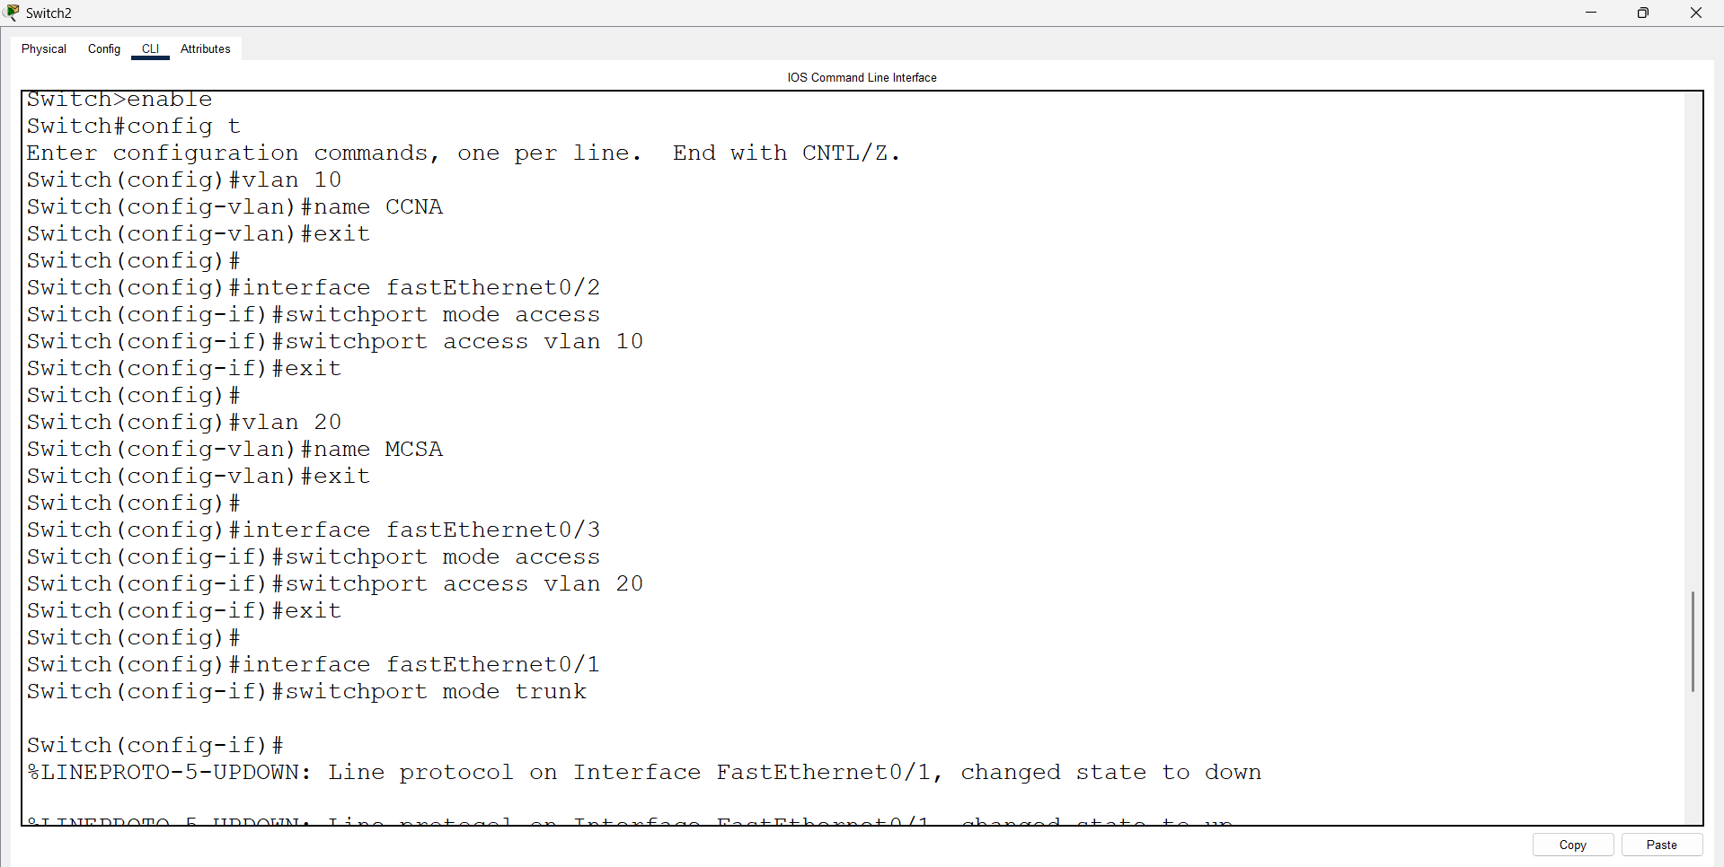

Open pc 0 – cmd prompt – type command
>ping 10.0.0.4

